EMBEDDED SYSTEM AND DESIGN
EXPERIMENT NO. 3

WEATHER MONITORING

Name: Raphael S. Nano

Course/Section: CPE161P / A1

Date of Performance: November 28-29, 2023
Date of Submission: November 30, 2023

Ma'am Cyrel Manlises
Instructor

DISCUSSION

Real-time weather monitoring systems are prevalent applications in mobile embedded systems. With the use of continuous monitoring and prediction of weather patterns, these systems serve as the center for meteorological expertise, as they collect and analyze parameters with speed and precision. Through a set of sensors and grounded measuring instruments, they cover a wide range of analysis for the weather reports. With that being said, a simple weather monitoring system was developed using the Arduino Uno as the center, temperature sensor for the input, and LCD for the display of values.

The objectives of this experiment are as follows:
1. To demonstrate how a a weather monitoring system works in real-time.
2. To be able apply what you have learned in logic circuits and switching theory, microprocessors, and CPE160P.
3. To be able to apply real-time embedded system using arduino kit.

The materials utilized for this experiment include the Arduino Uno, the DHT11 temperature and humidity sensor, and the Liquid crystal display with an inter-integrated IC. For the libraries, the dht.h was used for the DHT11 temperature sensor, the LiquidCrystal_I2C.h was used for the LCD, and String.h was used for the displaying of area being considered.
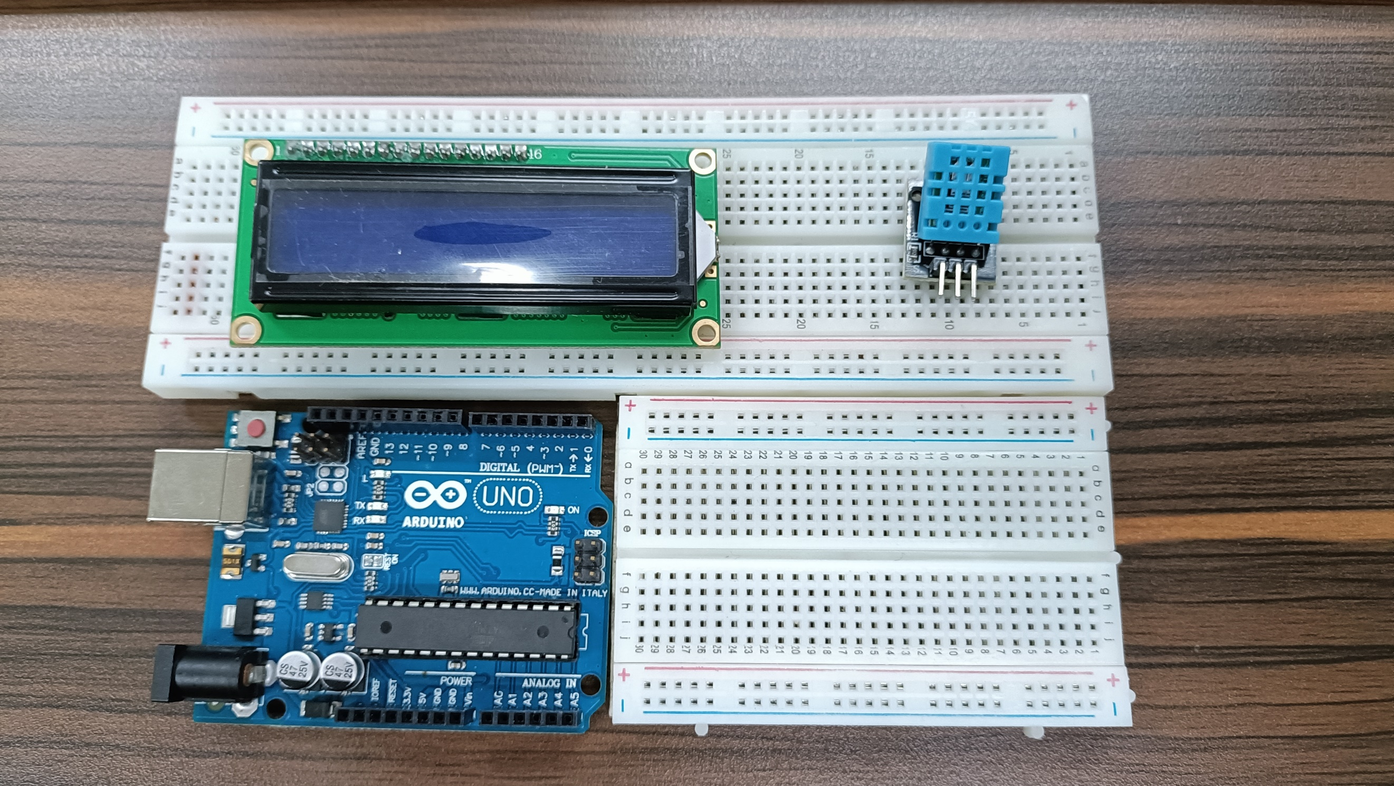

Figure 1. Major Components for the Experiment

The primary objective for experiment 3 is to simulate a weather monitoring system that operates in real-time. There are 5 areas or conditions where the temperature should be measured and should change accordingly: Room temp, Hands, Outside-the-room temperature, inside the bag, and in the comfort room.
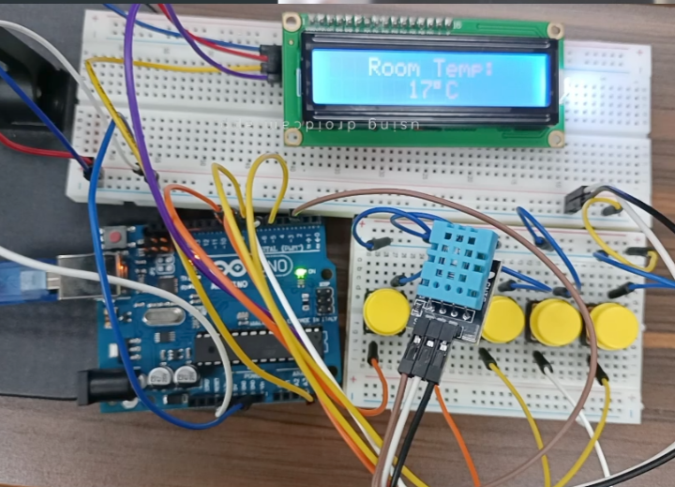

Figure 2. Final Output of the Experiment

The DHT11 is simply activated using the read11() function so that the value will be read. Moreover, a separate function named temp() was constructed, which is used to return the value of the sensed temperature using the DHT.temperature.

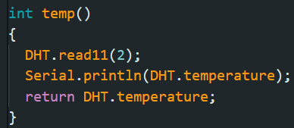

Figure 3. Codes for the counter() function

Before the detection of temperature, "Weather Monitoring" will be first displayed for 5 seconds as a starter for the system. For the displaying of area being considered, 5 buttons were added, one for each area: the classroom, hands, outside, bag, and in the comfort room. When the specific button is pressed, the string lcdVal will be initialized with that specific value.
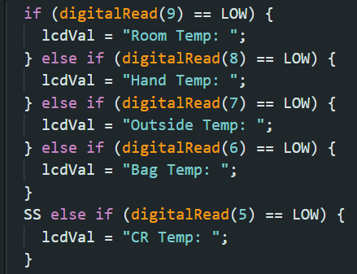

Figure 4. Conditions for LCD Titles
Then, for the displaying of values, the LCD simply uses the print() function to display the sensed temperature with the temp() module. With the use of (char)223, the degree symbol was displayed and a "C" was printed afterwards to represent degrees Celsius.
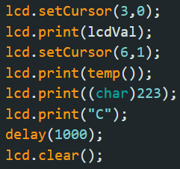

Figure 5. LCD Printing Codes

For the final outputs of the system, the 5 areas or conditions were tested, wherein the time range is only 5 minutes. The first test is the room temperature. Since the classroom is quite cold due to the air conditioner, the room temperature is low. It ranged from 19 degrees and went lower to 17 degrees at the end.
The second test is the hand temperature. It was a continuous detection of temperature. Hence, after the 17 degrees room temperature, it went up to 27 degrees, which is why the hands were hotter than the room temperature.
The next test is the outside temperature. After going outside the classroom, the temperature was measured. From a stable 22 degrees celsius, it rose to 26 degrees. This proves that the temperature outside the classroom is hotter than the temperature inside the classroom.
The fourth test is the temperature inside the comfort room. Although it was not quite different compared to the outside temperature, the temperature changed from 26 degrees celsius to 29 degrees celsius. Since there is an exhaust and the room is near the smoky area outside the school, it is very plausible that it is hotter compared to somewhere far from that area.
The last test is the temperature inside the bag. In this case, since the bag is also inside the classroom, there is a chance that no change can be seen. The detection of the temperature started at 20 degrees celsius, and after 5 minutes, the temperature became 21 degrees celsius, meaning that it is a bit hotter inside the bag.
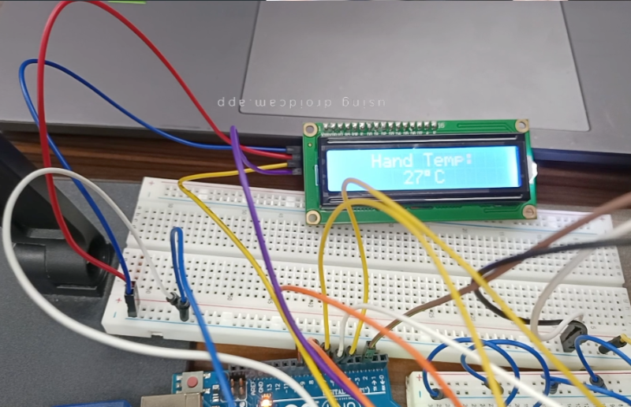
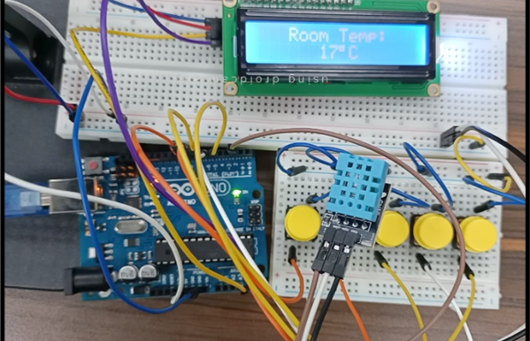
(b)
(a)

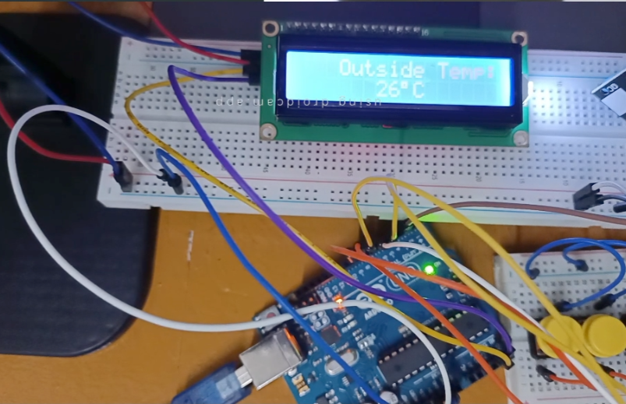
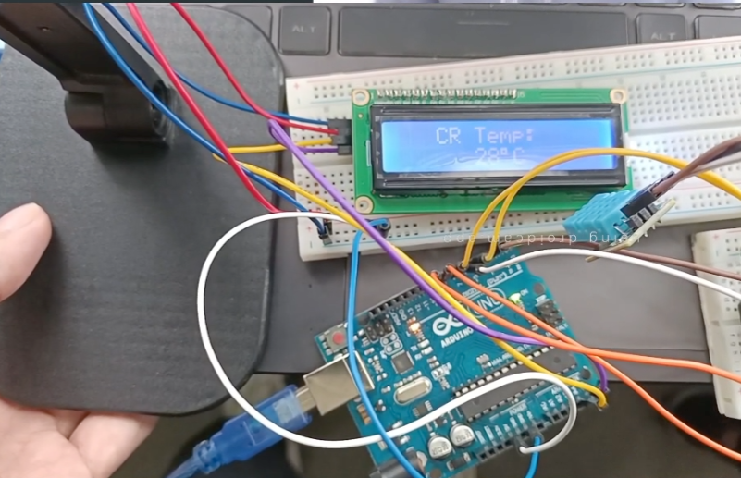
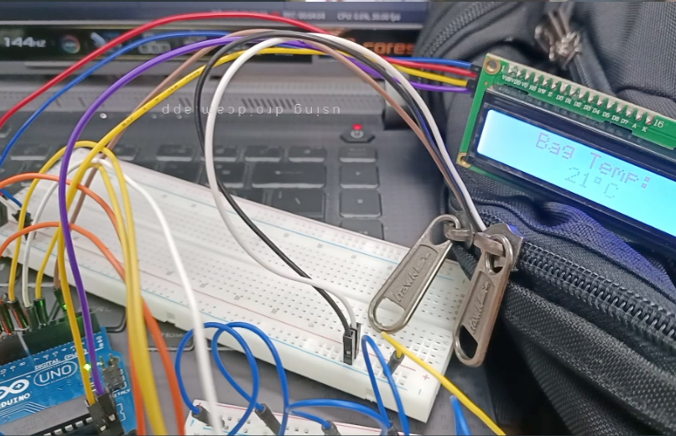
Figure 6. Sample Outputs: Temperatures for (a) Room, (b) Hands, (c) Outside-the-Room, (d) Comfort Room, (e) Inside the bag
(c)
(d)
(e)
CONCLUSION
In conclusion, for the first objective, the weather monitoring system works in real-time with the use of two main functions: (1) the detection of temperature using DHT11, reading the value using read11() and returning the value of its temperature, and (2) the displaying of values using the LCD.print() function, wherein the area being considered depends on what button was pressed and the value returned by the temp() function will be displayed on the second row. As the second objective was achieved, the use of microprocessors, logic circuits, and switching theory, as well as the teachings in CPE160P, was shown using series connections, pin arrangements, and sensor and LCD activation. Lastly, to achieve the third objective, the real-time weather monitoring system was successfully constructed and shown in a basic handshaking by applying various variables, modules, and invoking such functions to design an embedded system. The temperatures were accurately recorded within the 5-minute time range, wherein the changes in temperatures were recorded successfully.

